**Experiment – 10**

**Building using Blender**

1. Create a plane and extrude it upwards to create a cuboid like surface.
2. Insert it and Extrude the new face upwards to create the upper region of the building.
3. At the roof select the roof inset it and extrude it a bit downwards to create the terrace.
4. Add any signal antenna or any kind of strike termination device on the top if needed by using circle and loop cuts.
5. You can use bevel or extrude/intrude to change the angle/shape of the building as per your desire.
6. On the main Upper region Use subdivide on the faces to create window surfaces on the building.
7. Use Select Similar to select the all similar faces and create a material for them.
8. In the material we can add a transparent surface or a very shiny surface by maximum metallic and minimum roughness.
9. Select the vertices of the subdivide faces and add a coloured material to the edges as per the choice.
10. Color the base as per the choice.
11. Use two loop cuts on the base to create a rectangular face and delete the face to create the door.
12. Add other additional textures and materials in the shading tab to create a better loop

**Snapshots:**

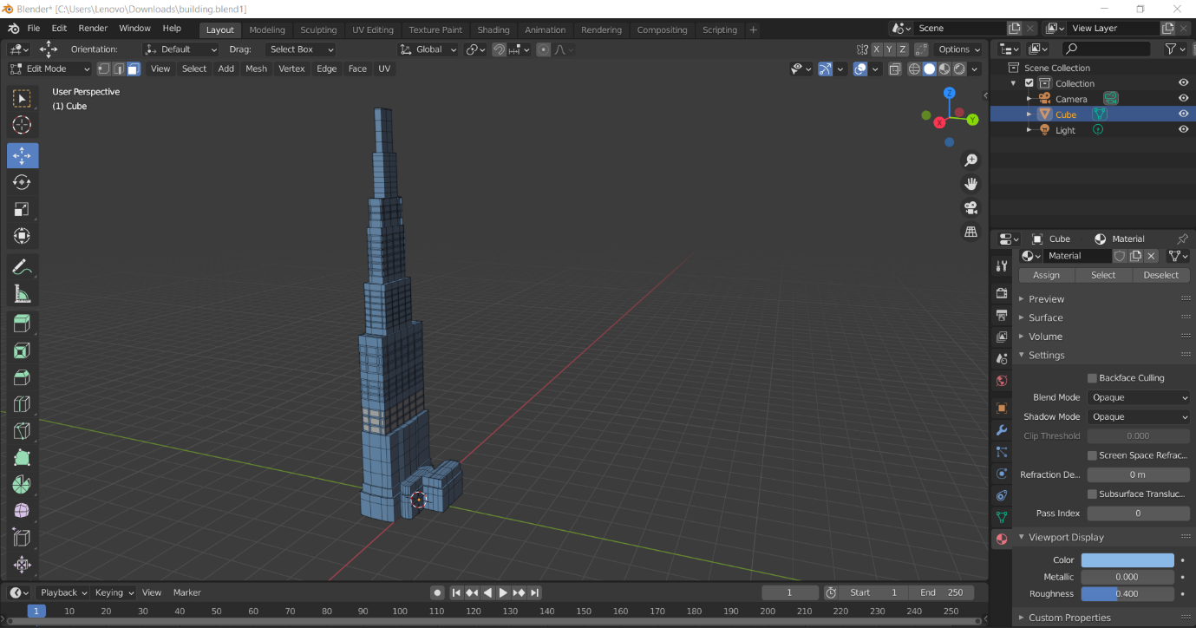

**Link:**

<https://drive.google.com/drive/folders/1yPbP2EAWuqEORJ2kjLHFM-wkl8WCkjnL?usp=sharing>